**BCA-412 VISUAL PROGRAMMING UNIT 1 NOTES**

1.1 The concept of computer programming

Programming means designing a set of instructions to instruct the computer to carry out certain jobs that are very much faster than human beings can do. The earliest programming language is called machine language which uses the binary code(comprises 0 and 1) to communicate with the computer. However, the machine language is extremely difficult to learn. Fortunately, scientists have invented some high-level programming languages that are much easier to master. Among the high-level programming languages are Java, [Javascript](https://javascript-tutor.net/index.php/tutorial/), C, C++, c# and Visual Basic.

### 1.2 What is Visual Basic?

Visual Basic is a third-generation event-driven programming language first released by Microsoft in 1991. It evolved from the earlier DOS version called BASIC. BASIC means Beginners' All-purpose Symbolic Instruction Code. Since then Microsoft has released many versions of Visual Basic, from Visual Basic 1.0 to the final version Visual Basic 6.0. Visual Basic is a user-friendly programming language designed for beginners, and it enables anyone to develop GUI window applications easily.

In 2002, Microsoft released Visual Basic.NET(VB.NET) to replace Visual Basic 6. Thereafter, Microsoft declared VB6 a legacy programming language in 2008. Fortunately, Microsoft still provides some form of support for VB6. VB.NET is a fully object-oriented programming language implemented in the .NET Framework. It was created to cater for the development of the web as well as mobile applications. However, many developers still favor Visual Basic 6.0 over its successor Visual Basic.NET.

### 1.3 What programs can you create with Visual Basic 6?

In VB 6, you can create any program depending on your objective. For math teachers, you can create mathematical programs such as [Geometric Progression](http://www.vbtutor.net/VB_Sample/GP.htm), [Quadratic Equation Solver](http://www.vbtutor.net/VB_Sample/QESolver.htm), [Simultaneous Equation Solver](https://www.vbtutor.net/VB_Sample/simuleq.htm) ,[Prime Number Tester](https://www.vbtutor.net/VB_Sample/Prime.htm), [Factors Finder](https://www.vbtutor.net/VB_Sample/factors%20Finders.html), [Quadratic Function Graph Plotter](https://www.vbtutor.net/VB_Sample/QGraphplotter.htm) and so on. For science teachers, you can create simulation programs such as [Projectile](https://www.vbtutor.net/VB_Sample/projectile.htm), [Simple Harmonic Motion](https://www.vbtutor.net/VB_Sample/shm.htm), [Star War](https://www.vbtutor.net/VB_Sample/starwar.htm)  etc. If you are in business, you can also create business applications such as [inventory management system](https://www.vbtutor.net/index.php/2013/02/03/inventory-management-system-2/) , [Amortization Calculator](https://www.vbtutor.net/VB_Sample/amortize.htm) , [investments calculator](https://www.vbtutor.net/VB_Sample/Investment.htm), point-of-sale system, payroll system, accounting program and more to help manage your business and increase productivity. For those of you who like games , you can create programs such as [slot machine](https://www.vbtutor.net/VB_Sample/vbslot2.htm), [reversi](https://www.vbtutor.net/VB_Sample/reversi.htm), [tic tac toe](https://www.vbtutor.net/VB_Sample/tictactoe.htm) and more.

### 1.4 The Visual Basic 6 Integrated Development Environment

After installing the vb6 compiler, the icon will appear on your desktop or in your programs menu. Click on the icon to launch the VB6 compiler. On start up, Visual Basic 6.0  will display the following dialog box as shown in Figure 1.1.

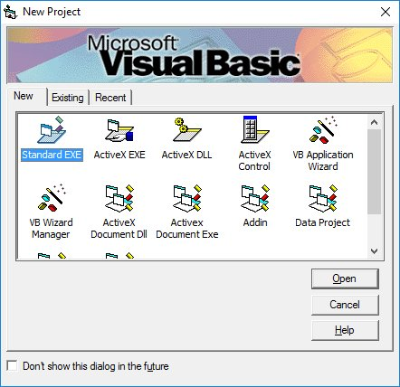Figure 1.1: New Project Dialog

You can choose to either start a new project, open an existing project or select a list of recently opened programs. A project is a collection of files that make up your application. There are various types of applications that we could create, however, we shall concentrate on creating Standard EXE programs (EXE means executable). Before you begin, you must think of an application that preferably have commercial ,educational or recreational value. Next, click on the Standard EXE icon to go into the actual Visual Basic 6 programming environment.

When you start a new Visual Basic 6 Standard EXE project, you will be presented  with the Visual Basic 6 Integrated Development Environment (IDE). The Visual Basic 6 Integrated Programming Environment is shown in Figure 1.2. It consists of the toolbox, the form, the project explorer and the properties window.

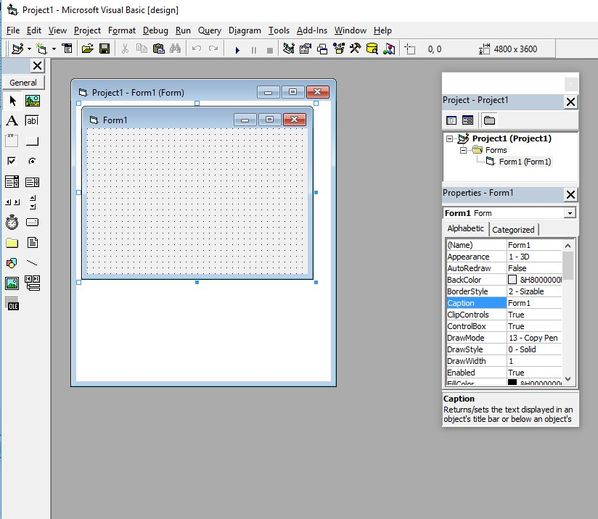Figure 1.2: VB6 Programming Environment

The Form is the primary building block of a Visual Basic 6 application. A Visual Basic 6 application can actually comprise many forms, but we shall focus on developing an application with one form first. We will learn how to develop applications with multiple forms later. Before you proceed to build the application, it is a good practice to save the project first. You can save the project by selecting Save Project from the File menu, assign a name to your project and save it in a certain folder. You shall now proceed to learn Visual Basic programming from the next lesson onwards.

### 2.1 Creating Your First Application

First of all, launch Microsoft Visual Basic 6 compiler that you have installed earlier. In the New Project Dialog , choose Standard EXE to enter Visual Basic 6 integrated development environment. In the VB6 IDE, a default form with the name Form1 will appear. Next, double click on Form1 to bring up the source code window for Form1, as shown in Figure 2.1.

The top of the source code window consists of a list of objects and their associated events or procedures. In the source code window, the object displayed is Form1 and the associated procedure is Load.

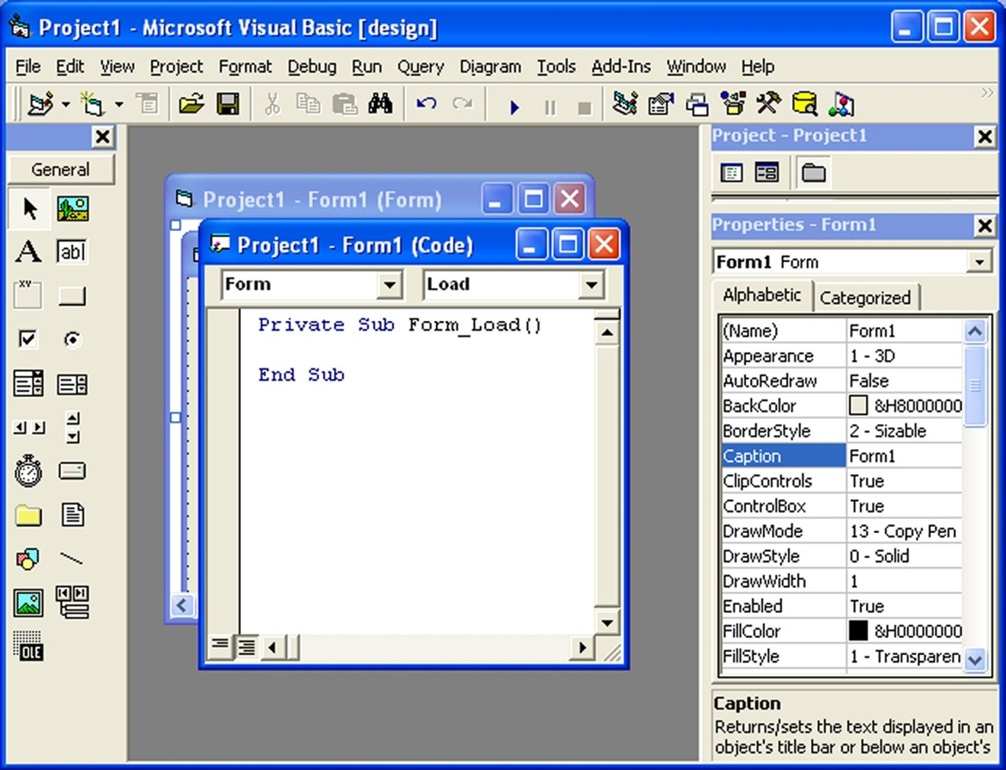

Figure 2.1 The VB6 Source Code Window

When you click on the object box, the drop-down list will display a list of objects you have inserted into your form, as shown in figure 2.2. Here, you can see a form with the name Form1, a command button with the name Command1, a Label with the name Label1 and a Picture Box with the name Picture1.

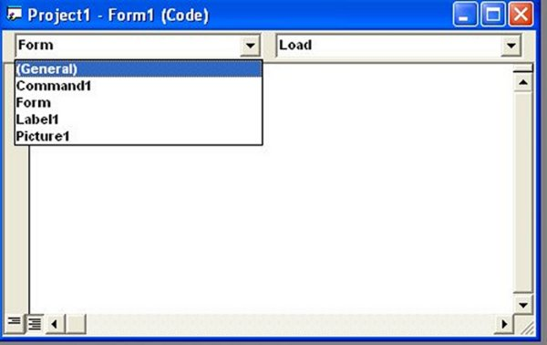

Figure 2.2: List of Objects

Similarly, when you click on the procedure box, a list of procedures associated with the object will be displayed , as shown in Figure 2.3. Some of the procedures associated with the object Form1 are Activate, Click, DblClick (which means Double-Click) , DragDrop, keyPress and more. Each object has its own set of procedures. You can always select an object and write codes for any of its procedure in order to perform certain tasks.

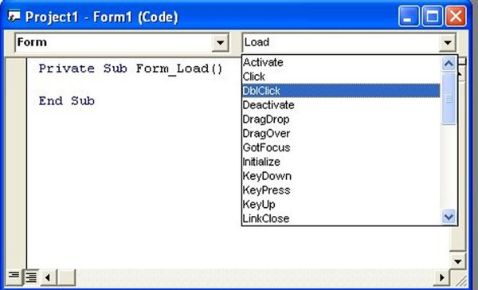

Figure 2.3 List of Procedures

You do not have to worry about the beginning and the end statements (i.e. Private Sub Form_Load.......End Sub.); Just key in the lines in between the above two statements exactly as are shown here. When you press F5 to run the program, you will be surprised that nothing showed up .In order to display the output of the program, you have to add the Form1.show statement like in Example 2.1.1  or you can just use Form_Activate ( )  event procedure as shown in example 2.1.2. The command Print does not mean printing using a printer but it means displaying the output on the computer screen. Now, press F5 or click on the run button to run the program and you will get the output as shown in Figure 2.4.

You can also perform arithmetic calculations as shown in Example 2.1.2. VB uses **\*** to denote the multiplication operator and **/** to denote the division operator. The output is shown in Figure 2.5, where the results are arranged vertically.

#### Example 2.1.1

Private Sub Form_Load ( )

Form1.show

Print "Welcome to Visual Basic tutorial"

End Sub

#### Example 2.1.2

Private Sub Form_Activate ( )

Print 20 + 10  
Print 20 - 10  
Print 20 * 10  
Print 20 / 10

End Sub

You can also use the **+** or the **&** operator to join two or more texts (string) together like in example 2.1.4 (a) and (b)

#### Example 2.1.4(a)

Private Sub

A = "Tom"  
B = "likes"  
C = "to"  
D = "eat"  
E = "burger"  
Print A + B + C + D + E

End Sub

#### Example 2.1.4(b)

Private Sub

A = "Tom"  
B = "likes"  
C = "to"  
D = "eat"  
E = "burger"  
Print A & B & C & D & E

End Sub

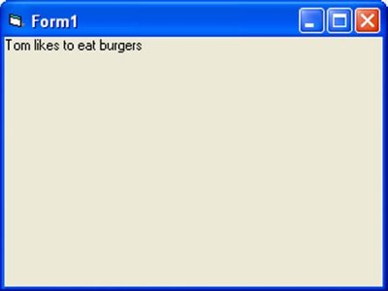

### 2.2 Steps in Building a Visual Basic Application

Step 1: Design the interface by adding controls to the form and set their properties

Step 2:Write code for the event procedures

#### Example 2.2 Changing Background and Foreground Color at Random

In this example, we want to show you how to write code to change the background and the foreground color randomly. We will place two command buttons and a label on the form. One of the command buttons will be used to change the background color while the other one will be used to change the foreground color. The Label is for displaying the foreground color. There are two events here, **change background color** and **change foreground color**. Therefore, we need to write code for the two event procedures.

To make the program more interesting, we will use the Rnd() function, the Int() function and the RGB codes to change the color randomly. The Rnd() function creates a random number between 0 and 1 and the RGB code uses a combination of three integers to form a certain color. The Int() is a function that converts a number into an integer by truncating its decimal part and the resulting integer is the largest integer that is smaller than the number. For example, Int(0.2)=0, Int(2.4)=2, Int(4.8)=4. Therefore, Int(Rnd()*256) returns the smallest integer 0 and the biggest integer 255. The format of RGB code is RGB(a,b,c), where a, b, c range from 0 to 255. For example, RGB(255,0,0) is red, RGB(255,255,255) is white and (0,0,0) is black. Do not worry about the jargons, you will learn them in later lesson.

Now, rename the controls as follows:

* Form1-MyForm
* Label1-LblMessage
* Command1-cmd_bgColor
* Command2-cmd_fgColor

Next, change the caption of the Label to "Please Change My Color". In addition, change the caption of Command1 button to "Change Background Color" and change the caption of Command2 button to "Change Foreground Color"

Now, enter the following code

Private Sub cmd_bgColor_Click()

Dim r, g, b As Integer

r = Int(Rnd() * 256)

g = Int(Rnd() * 256)

b = Int(Rnd() * 256)

MyForm.BackColor = RGB(r, g, b)

End Sub

Private Sub Cmd_fgColor_Click()

Dim r, g, b As Integer

r = Int(Rnd() * 256)

g = Int(Rnd() * 256)

b = Int(Rnd() * 256)

Lbl_Msg.ForeColor = RGB(r, g, b)

End Sub

When you run the program, each time you press on the 'Change Background Color' button, you will see different background color. Similarly, each time you press on the 'Change Foreground Color', you will see the message on the Label changes color. The output is shown in Figure 2.8.

